DS LAB
NAME : BHOOMIKA
PROGRAM 2 : BFS AND DFS
OUTPUTS:
BFS
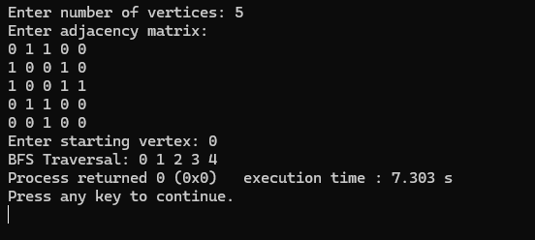
DFS

